Fiki Digital Market

Software Architecture Document

Version 1.0

Revision History

|  |  |  |  |
| --- | --- | --- | --- |
| **Date** | **Version** | **Description** | **Author** |
| 26/Nov/2024 | 0.0 | Draft version | Trần Phương Nam |
|  |  |  |  |
|  |  |  |  |
|  |  |  |  |

Table of Contents

**1. Introduction 4**

1.1 Purpose 4

1.2 Scope 4

1.3 Definitions, Acronyms, and Abbreviations 4

1.4 References 5

1.5 Overview 5

**2. Architectural Representation 5**

Logical View 5

Deployment View 5

Data View 5

**3. Architectural Goals and Constraints 5**

**4. Use-Case View 6**

4.1 Use-Case Realizations 7

Book management 7

Readers management 9

Borrow and Return Book Management 12

Account Management 14

**5. Logical View 16**

5.1 Overview 16

5.2 Architecturally Significant Design Packages 17

**6. Process View 17**

**7. Deployment View 17**

**8. Implementation View 17**

8.1 Overview 17

8.2 Layers 17

**9. Data View (optional) 17**

**10. Size and Performance 17**

Volumes 17

Performance 17

**11. Quality 17**

Software Architecture Document

# Logical View

## Overview

An overview of the logical architecture is provided, detailing the overall structure of the design model through its package hierarchy and layered organization. The logical view of the Fiki Digital Market system consists of three main packages:

- **Model** is a collection of classes responsible for directly handling and presenting the data, logic, and rules of the Fiki Digital Market system within the view.

**- View** consist of classes that produce output representations of information for the user, reflecting updates made in the model.

- **Controller** comprises classes that issue commands to the model to modify its state (e.g., updating product in the shopping cart) and send data to the associated view to adjust the presentation of the model.

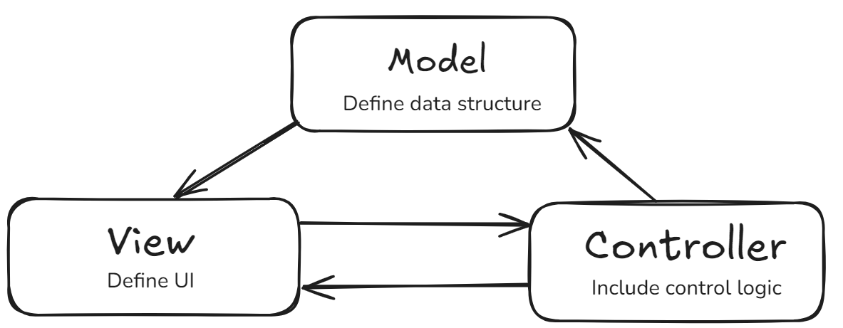

## 

## Architecturally Significant Design Packages

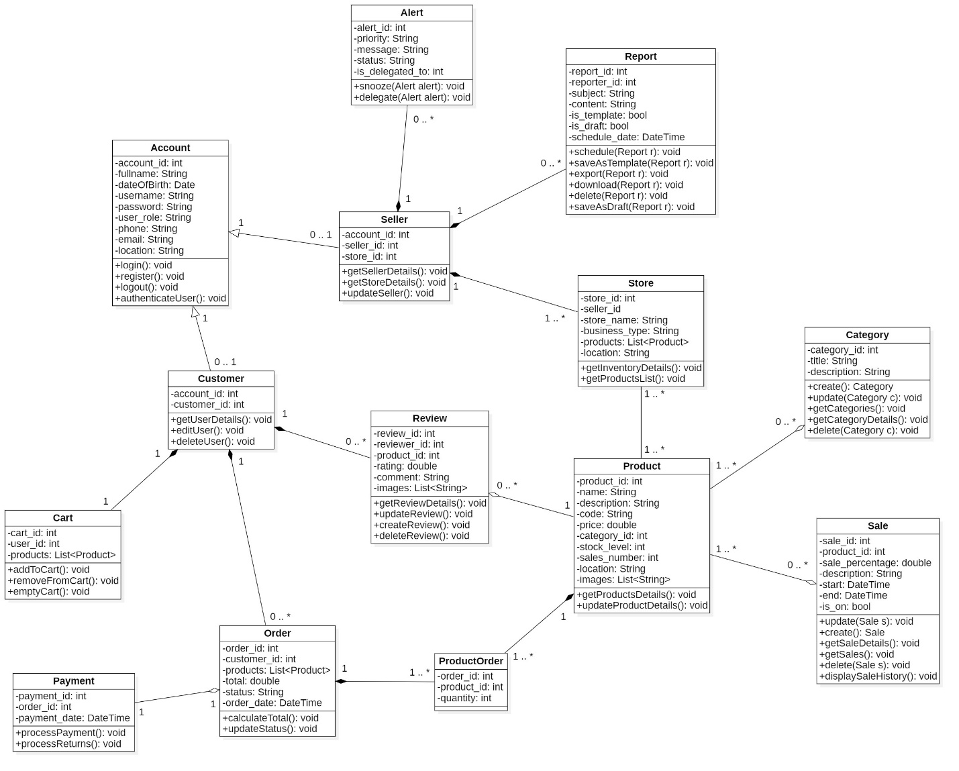

# Process View

# Deployment View

# Implementation View

## Overview

## Layers

# Data View (optional)

# Size and Performance

* 1. **Volumes**
* Maximum simultaneous user: 200.000 users.
* Database capacity: at least 2TB for storage capacity.
  1. **Performance**
* Page load time for the homepage should not exceed 1.5 seconds on a high-speed internet connection.
* Product images should load completely within 2 seconds after the page content is displayed.
* Inventory updates from the database should reflect in the frontend within 1 second.
* Payment gateway processing time should not exceed 2 seconds.

# Quality

The system architecture satisfies the subsequent quality standards:

* Scalability: The system architecture should support seamless scaling to accommodate increased user traffic and data without performance issues.
* Maintainability: The system should be modular, with well-defined components and interfaces, allowing independent development, testing, and maintenance.
* Security: Regular security audits and vulnerability assessments should be conducted to identify and mitigate risks.
* The application is compatible with and can be installed on both Android and iOS devices.